The first steps were importing the required libraries, creating the functions we will use frequently (show image and plot comparison), and reading the images using io.imread to set up the whole situation.

**Task 1**

To fix the damaged image we did as follows:

* Reshape the image to 512 by 512 (as previously it wouldn’t fix the damaged part properly)

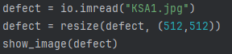

* Create the defect mask using the shape of the original image then by pure trial and error to find the correct area for the damaged part (and including some neighbors)



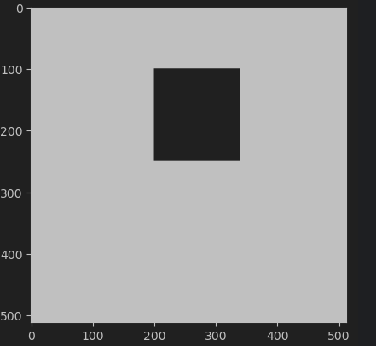

* Use inpaint_biharmonic with channel axis = -1 to get the rgb channel specifically then plot comparison

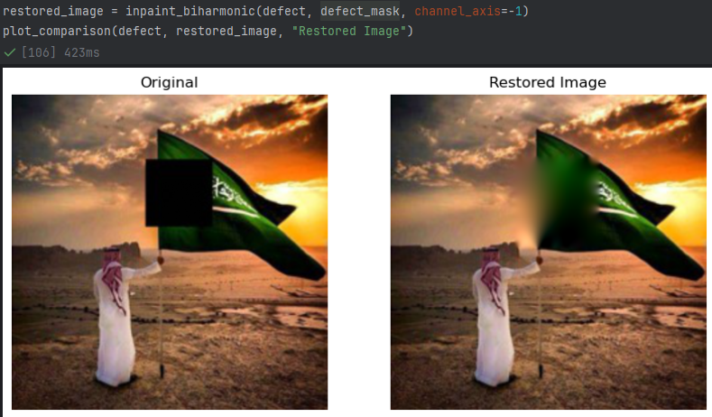

**Task 2 and Task 3**

To solve both together, we applied the following steps:

* Find the defect mask for the text at the top right corner of the image and the logo at the bottom right corner of the image

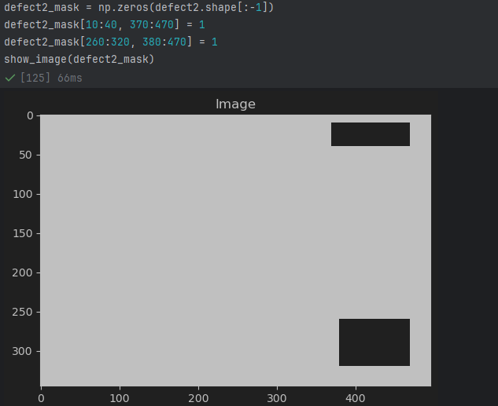

* Use inpaint_biharmonic with channel axis = -1 to get the rgb channel specifically then plot comparison but this time the mask covers both the logo and the text.

